A Simple http-server using node and express

Setp1:

Initialize an empty node project using “npm init”, and install express library. Using command “npm install express”.

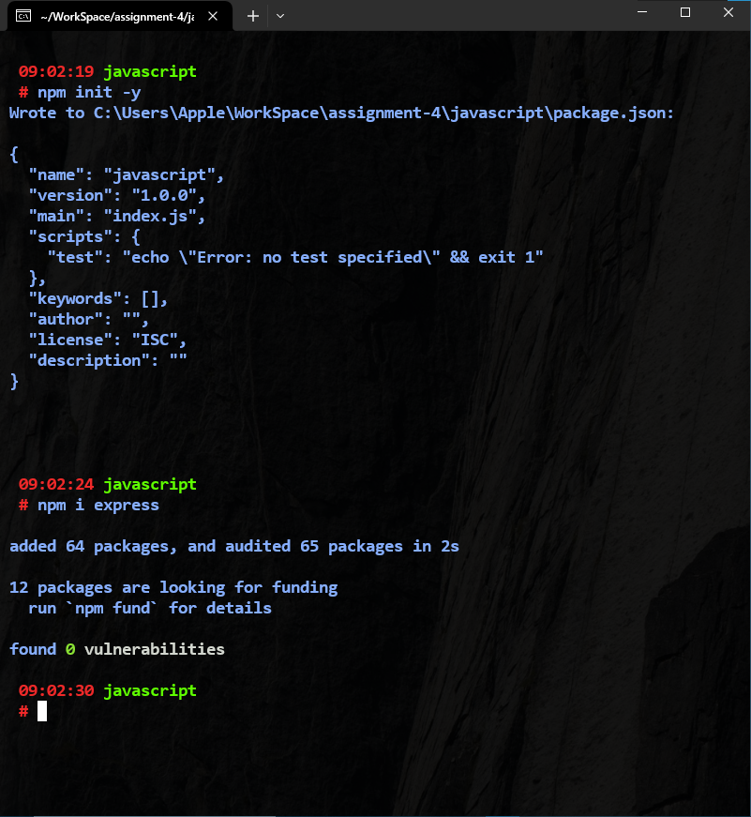

Step2:

Write a simple http-server using express.

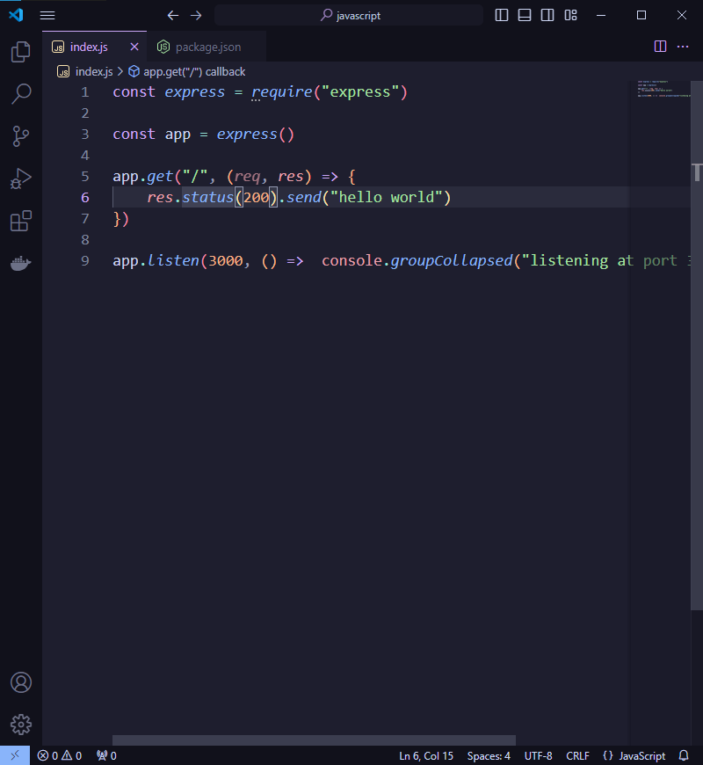

Step4:

Make changes in package.json, add “dev : node index.js” in scripts object.

After that start the server using command “npm run dev”

